
RECORD OF EXPERIMENTS
Register Number: 231801093
Academic Year 2025 – 2026
List of Experiments
- Private Cloud using OpenStack
- PaaS in Public Cloud Using Render
- Setting Up Hybrid Cloud Connectivity Using Cisco Packet Tracer
- Virtual Private Server (VPS) Provisioning and Configuration
- Cloud Backup and Migration using Google Drive
- CDN Service Selection and Configuration

Ex: 4 | Virtual Private Server (VPS) Provisioning and Configuration
Date:05/08/2026

Aim
To provision a Virtual Private Server (VPS) using VirtualBox, install Ubuntu Server, configure network settings (IP address, subnet mask, gateway, DNS), and enable SSH for secure remote access.

Understanding VPS and Networking Concepts
A Virtual Private Server (VPS) is a software-based server created using virtualisation technology. It runs its own operating system, storage, memory, and network configuration while sharing the underlying physical hardware — a core building block of cloud infrastructure.
- IP Address: a unique identifier for a device on a network.
- Subnet Mask: defines the network and host portions of an IP address.
- Gateway: provides access to networks outside the local segment.
- DNS: translates domain names into IP addresses.
- SSH: a secure protocol used for remote administration of Linux systems.

Procedure
- Open the Ubuntu terminal and verify internet connectivity: ping google.com.

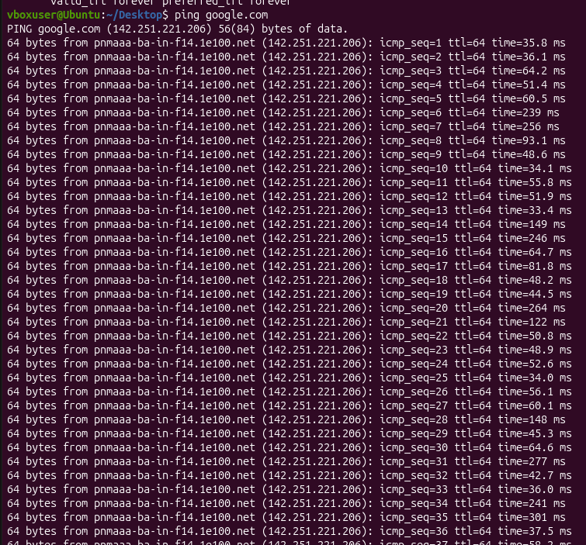
Figure 4.1: Verifying internet connectivity.

- Examine the network routing table: ip route.


Figure 4.2: Viewing the routing table.
- Check the DNS configuration: cat /etc/resolv.conf.

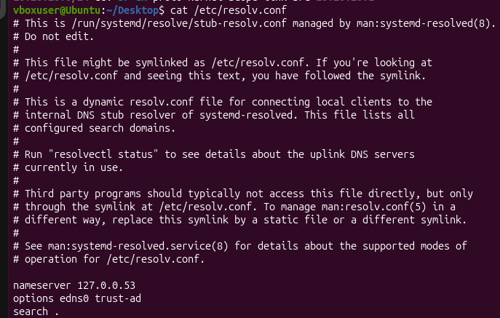
Figure 4.3: Viewing DNS configuration.
- Update the package list: sudo apt update.

- Install the OpenSSH server package: sudo apt install openssh-server -y.

- Enable and start the SSH service: sudo systemctl enable ssh, followed by sudo systemctl start ssh.

- Verify that the SSH service is running: sudo systemctl status ssh.

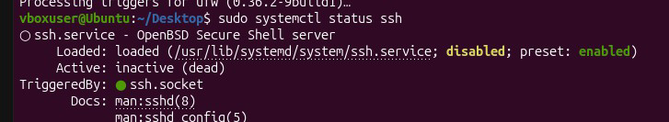
Figure 4.4: Confirming the SSH service is active.
- Retrieve the machine's IP address: hostname -I.

- Connect to the system remotely from another machine: ssh <username>@<IP_address>.
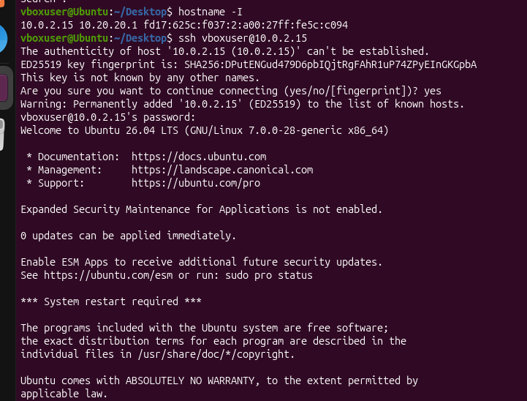
Figure 4.5: Successful SSH login showing the "Welcome to Ubuntu" message.

Conclusion
The Ubuntu system was successfully provisioned as a VPS and configured with the required network settings. OpenSSH was installed and enabled, and remote access was verified via SSH, confirming secure administration capabilities.

